**Hands-on Lab: Using Views in MySQL using phpMyAdmin**

**Estimated time needed:** 20 minutes

In this lab, you will learn how to create tables and load data in the MySQL database service using the phpMyAdmin graphical user interface (GUI) tool.

**Software Used in this Lab**

In this lab, you will use [MySQL](https://www.mysql.com/?utm_medium=Exinfluencer&utm_source=Exinfluencer&utm_content=000026UJ&utm_term=10006555&utm_id=NA-SkillsNetwork-Channel-SkillsNetworkCoursesIBMDB0110ENSkillsNetwork24601058-2021-01-01). MySQL is a Relational Database Management System (RDBMS) designed to efficiently store, manipulate, and retrieve data.



To complete this lab you will utilize MySQL relational database service available as part of IBM Skills Network Labs (SN Labs) Cloud IDE. SN Labs is a virtual lab environment used in this course.

**Database Used in this Lab**

The database used in this lab is an internal database. You will be working on a sample HR database. This HR database schema consists of 5 tables called **EMPLOYEES**, **JOB_HISTORY**, **JOBS**, **DEPARTMENTS** and **LOCATIONS**. Each table has a few rows of sample data. The following diagram shows the tables for the HR database:

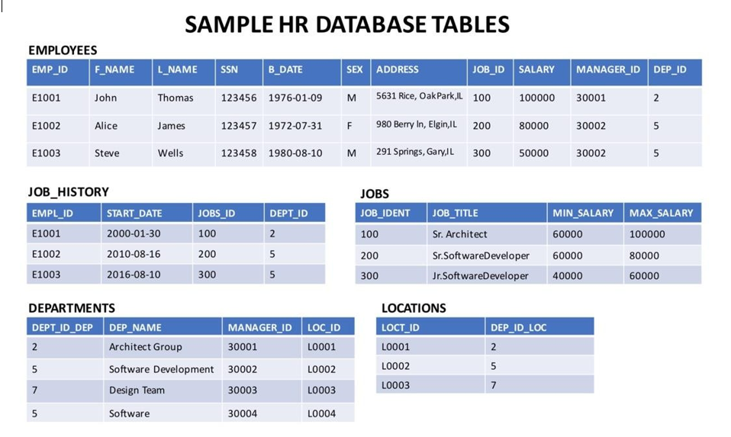

NOTE: This lab requires you to have all 5 of these tables of the HR database populated with sample data on MySQL. If you don't have the tables above populated with sample data on MySQL, please go through the lab below first:

[Hands-on Lab: Create and Load Tables using SQL Scripts](https://cf-courses-data.s3.us.cloud-object-storage.appdomain.cloud/IBMDeveloperSkillsNetwork-DB0201EN-SkillsNetwork/labs/MySQL/week2/Create_and%20_Load.md.html)

# Objectives

After completing this lab, you will be able to:

* Create a View and show a selection of data for a given table
* Update a View to combine two or more tables in meaningful ways
* Drop a created View  
  In this lab, you will learn about using views. In SQL, a view is an alternative way of representing data that exists in one or more tables. Just like a real table, it contains rows and columns. The fields in a view are fields from one or more real tables in the database. Though views can be queried like a table, views are dynamic; only the definition of the view is stored, not the data.

**How does the syntax of a CREATE VIEW statement look?**

1. 1
2. 2
3. 3
4. 4
5. CREATE VIEW view_name AS
6. SELECT column1, column2, ...
7. FROM table_name
8. WHERE condition;

Copied!

**How does the syntax of a REPLACE VIEW statement look?**

1. 1
2. 2
3. 3
4. 4
5. CREATE OR REPLACE VIEW view_name AS
6. SELECT column1, column2, ...
7. FROM table_name
8. WHERE condition;

Copied!

**How does the syntax of a DROP VIEW statement look?**

1. 1
2. DROP VIEW view_name;

**Exercise 1: Create a View**

In this exercise, you will create a View and show a selection of data for a given table.

1. Let’s create a view called **EMPSALARY** to display salary along with some basic sensitive data of employees from the HR database. To create the **EMPSALARY** view from the **EMPLOYEES** table, Copy the code below and paste it to the textarea of the **SQL** page. Click **Go**.
   1. 1
   2. 2
   3. 3
   4. CREATE VIEW EMPSALARY AS
   5. SELECT EMP_ID, F_NAME, L_NAME, B_DATE, SEX, SALARY
   6. FROM EMPLOYEES;

Copied!

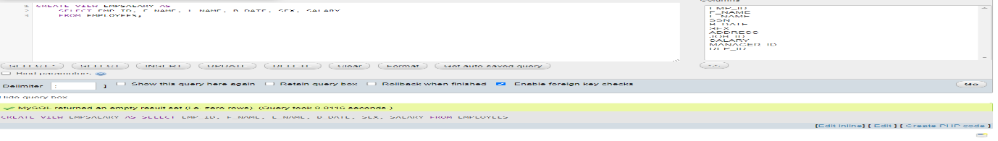

1. Using SELECT, query the **EMPSALARY** view to retrieve all the records.Copy the code below and paste it to the textarea of the **SQL** page. Click **Go**.
   1. 1
   2. SELECT * FROM EMPSALARY;

Copied!

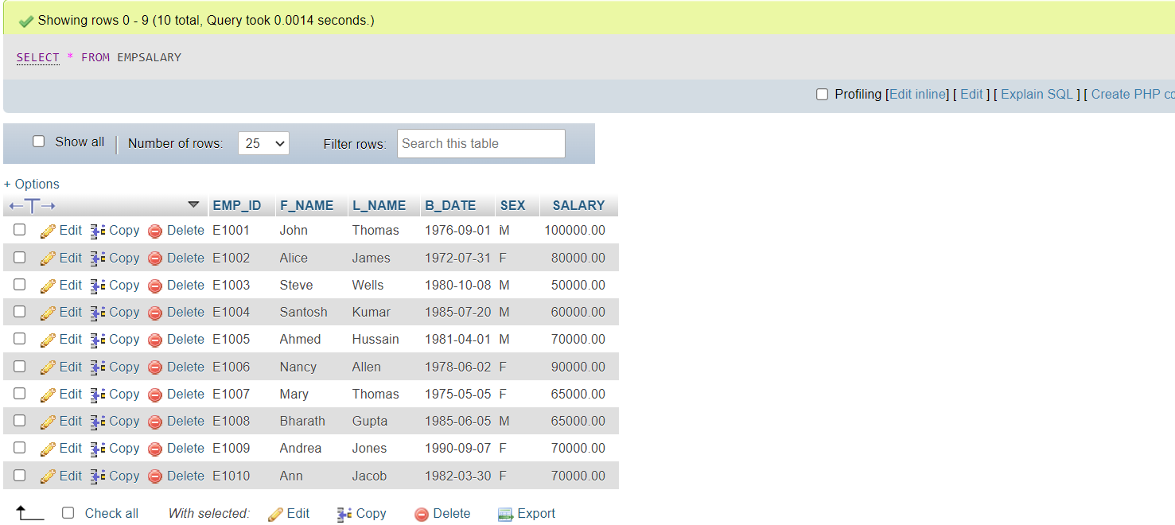

**Exercise 2: Update a View**

In this exercise, you will update a View to combine two or more tables in meaningful ways.

1. It now seems that the **EMPSALARY** view we created in exercise 1 doesn’t contain enough salary information, such as max/min salary and the job title of the employees. Let’s update the **EMPSALARY** view:
   * combining two tables **EMPLOYEES** and **JOBS** so that we can display our desired information from the HR database.
   * including the columns **JOB_TITLE, MIN_SALARY, MAX_SALARY** of the **JOBS** table as well as excluding the **SALARY** column of the **EMPLOYEES** table.

Copy the code below and paste it to the textarea of the **SQL** page. Click **Go**..

* + 1
  + 2
  + 3
  + 4
  + CREATE OR REPLACE VIEW EMPSALARY AS
  + SELECT EMP_ID, F_NAME, L_NAME, B_DATE, SEX, JOB_TITLE, MIN_SALARY, MAX_SALARY
  + FROM EMPLOYEES, JOBS
  + WHERE EMPLOYEES.JOB_ID = JOBS.JOB_IDENT;

Copied!

***NOTE:****Don’t worry if you don’t understand how to combine to two tables using implicit inner join. You will learn more about joins later on. For now, just think you are combining the data of two different tables,****EMPLOYEES****and****JOBS****by connecting their respective columns****JOB_ID****and****JOB_IDENT****since both the columns contain common unique data. You can have a look at the diagram (at the beginning of the lab) showing the tables for the HR database to observe how the****JOB_ID****and****JOB_IDENT****columns from the****EMPLOYEES****and****JOBS****tables respectively contain common unique data.*

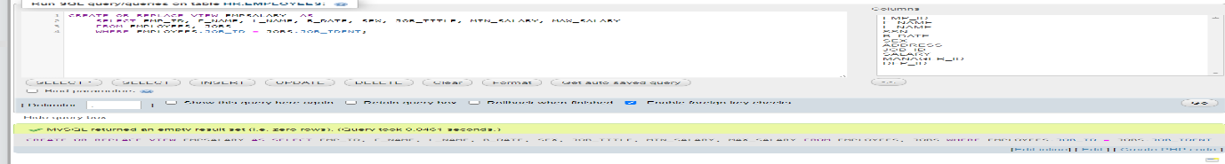

1. Using SELECT, query the updated **EMPSALARY** view to retrieve all the records. Copy the code below and paste it to the textarea of the **SQL** page. Click **Go**.
   * 1
   * SELECT * FROM EMPSALARY;

Copied!

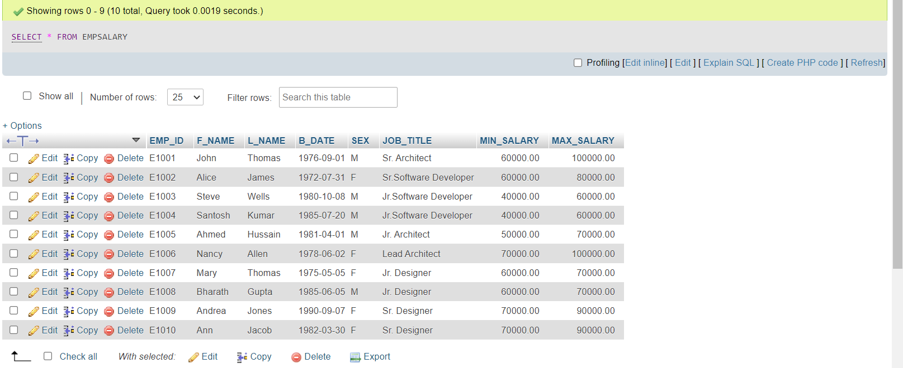

# Exercise 3: Drop a View

In this exercise, you will drop a created View.

1. Let’s delete the created **EMPSALARY** view. Copy the code below and paste it to the paste it to the textarea of the **SQL** page. Click **Go**..
   1. 1
   2. DROP VIEW EMPSALARY;

Copied!

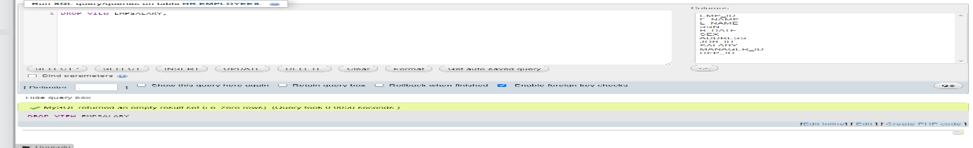

1. Using SELECT, you can verify whether the **EMPSALARY** view has been deleted or not. Copy the code below and paste it to the textarea of the **SQL** page. Click **Go**..
   1. 1
   2. SELECT * FROM EMPSALARY;

Copied!

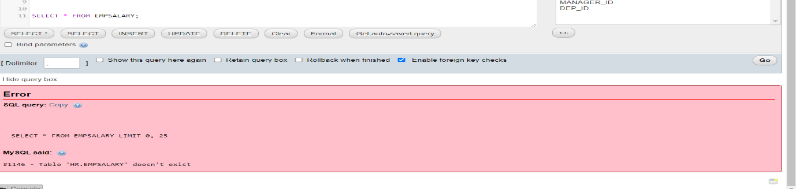

### Congratulations! You have completed this lab, and you are ready for the next topic.

# Author(s)

[Lakshmi Holla](https://www.linkedin.com/in/lakshmi-holla-b39062149/)

[Malika Singla](https://www.linkedin.com/in/malika-goyal-04798622/)

# Changelog

| **Date** | **Version** | **Changed by** | **Change Description** |
| --- | --- | --- | --- |
| 2023-05-04 | 0.2 | Rahul Jaideep | Updated Markdown file |
| 2021-11-01 | 0.1 | Lakshmi Holla, Malika Singla | Initial Version |

### IBM Corporation 2023. All rights reserved.